Supplementary materials

Buoyancy concept assessment items
Question1 | A small wooden bead is floating on the water. What happens when you put a large wooden bead that is made of the same material in the water? Provide detailed reasons for your answer.  A small wooden beads A big wooden beads
Question 2 | What happens when you put the small wooden bead used in question 1 and a same-sized metal bead in the water? Provide detailed reasons for your answer.  A small wooden beads A small metal beads
Question 3 | What happens when you put the small metal bead of question 2 and a wooden bead of the same weight in the water? (The metal bead and the wooden bead are made of the same materials as those used in questions 1 and 2.) Provide detailed reasons for your answer.  A small metal beads A wooden beads
Question 4 | There are two glass bottles of the same shape and size. A glass full of water sank below the water. What happens when you put an empty glass with a stopper in the water? Provide detailed reasons for your answer.  A glass full of water An empty glass with a stopper
Question 5 | There are two balloons of the same shape and size. An uninflated balloon was bound and put in the water. It sank below the water. What happens when you put an inflated balloon in the water? Provide detailed reasons for your answer.  An uninflated balloon An inflated balloon
Question 6 | 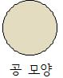  After creating a boat-shaped object from foil, we put it on the water. Then, we put five stones on the object. It does not sink below the water. What happens when you crumple up the boat and the stones in the foil and float it? Provide detailed reasons for your answer.  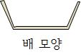
Question 7 | There are two identical weights. As shown in the figure, submerge the weights in the beaker each one at a different level. Which side tips? Provide detailed reasons for your answer.  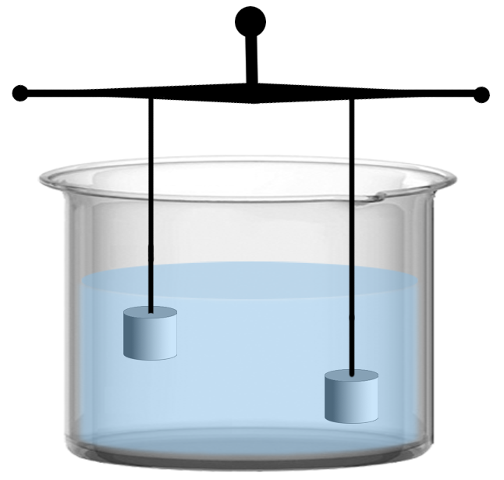
Question 8 | There are two identical weights. As shown in the figure, submerge the weights in the beaker. The left weight submerges completely into the beaker, but the right weight submerges only halfway. Which side tips? Provide detailed reasons for your answer.  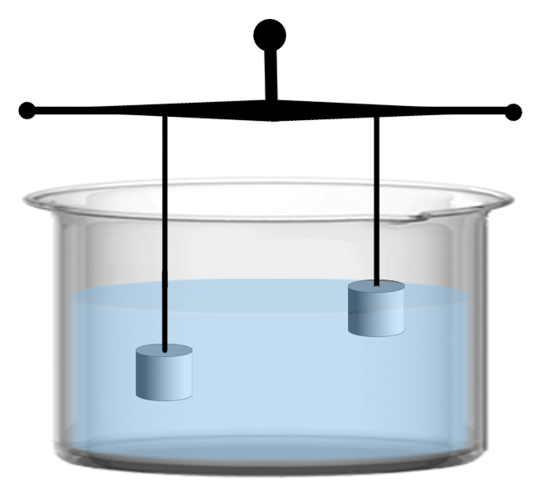
Question 9 | There are two identical weights. We place the weights on the hanging scale bar and maintain the balance. Then, we carefully submerge the weights into the beakers, one of which is a large beaker with lots of water, and the other is a small beaker with less water. Which side tips? Provide detailed reasons for your answer.  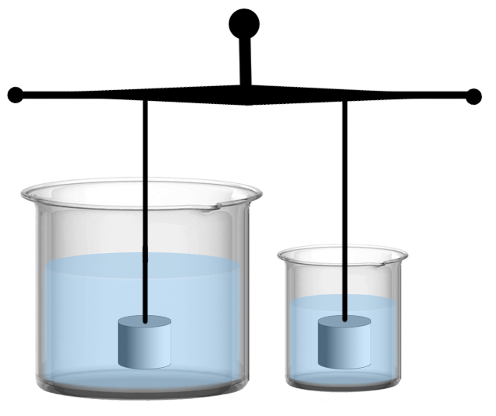
Question 10 | There are two identical weights. As shown in the figure, submerge the weights in the beaker. The left one lies down on its side and submerges, while the right one stands up and submerges in the beaker. Which side tips? Provide detailed reasons for your answer.  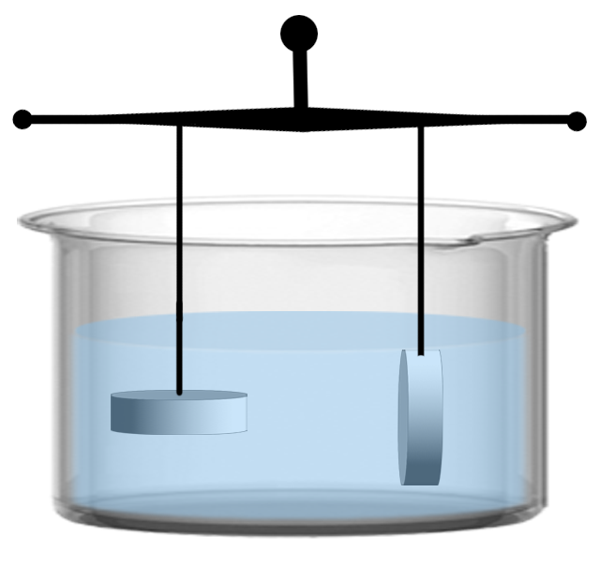
Question 11 | There are two weights of the same weight but different volumes. As shown in the figure, submerge the weights in the beaker. Which side tips? Provide detailed reasons for your answer.  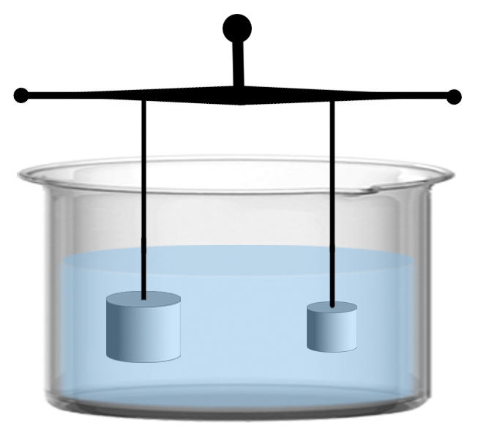
Question 12 | There are two weights of the same volume but different weights. As shown in the figure, submerge the weights in the beaker. Which side tips? Provide detailed reasons for your answer.  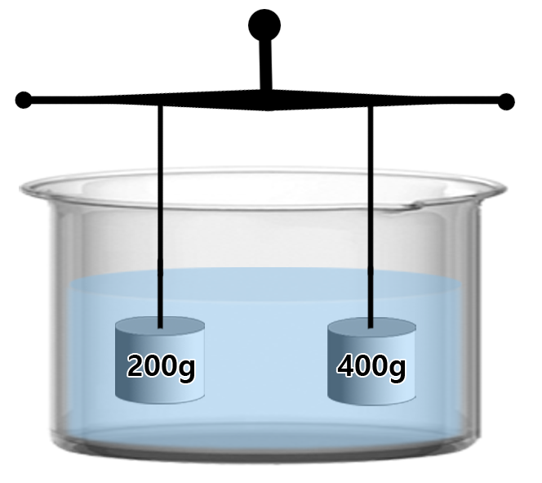
Question 13 | There are two plastic bags of water. As shown in the figure, submerge the plastic bags in the beaker. Which side tips? Provide detailed reasons for your answer. (Ignore the weight of the plastic bags.)  